

Usability Guide

This document will be a basic guide of how to use Bonk-Skins.io in the case that there is confusion about certain functions of the site.

Bonk-Skins.io is intended to be used with modern browsers.

(The latest version of Google Chrome is recommend).

# The Homepage

The hompage presents listings of any and all skins sorted by the newest to oldest. Each item in the list is one individual skin:

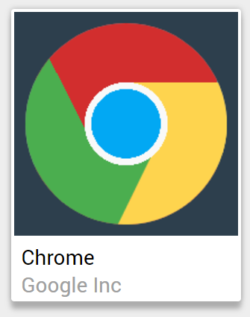

Clicking on the skin image will redirect you to the skin viewed in the skin editor in a read-only form. This is to allow you to view each element of the skin and understand how it was constructed.

Clicking on the skin authors name (In this case it is “Google Inc”), which is light grey, will take you to the authors profile.

Clicking “LOAD MORE” will dynamically load a new page of skins.

# The Header

Clicking the logo will redirect you back to the homepage.

Clicking “Log in” will open a modal that will allow you to log in to your Bonk-Skins.io account.

Clicking “Sign up” will open a modal that will allow you to create your own Bonk-Skins.io account. Simply insert your desired username, password and email (Your password is not stored and I, nor the site, knows your password). Once you have signed up you will be prompted to log in.

Click ESC or outside of any modal to close it.

The “New” button does nothing, but is merely an indication that the skins are sorted by newest to oldest.

The search bar allows you search through skins by keyword. This searches all the skin names and skin authors on the website and returns result that match the search query.

Clicking 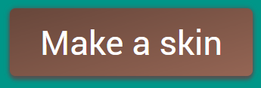 will redirect you to the skin editor.

**NOTE:** Make sure that you are logged in *before* you enter the skin editor, otherwise you cannot upload your skin to the online database, you can only download your skin to your PC.

# The Profile Page

The profile page is a page that shows skins created by an individual user. You get to this page either by clicking on an author’s name on a post, or by clicking your own name in the header.

In the header will be the users’ username as well as a number. This number represents the total amount of skins that individual user has created.

C:\Users\Matthew\Documents\Work\Year 12\IPT\Bonk-Skins Admin\sensai.png

# The Skin Editor

The skin editor is the main feature of the entire website, and is possibly one of the most complex. This is a graphical user interface that allows users to easily and quickly create their own skins.

Fortunately, there is a guided tutorial in the editor itself that takes you through the basic functions. **Remember to read and understand the short tutorial**.

C:\Users\Matthew\Documents\Work\Year 12\IPT\Bonk-Skins Admin\tutorial.png

Also notice that, if you’re not logged in, there is no  button in the header. You must be logged in to submit a skin to the database.

Logging in in the editor may clear your unsaved changes to your skin.